**UNIT-I**

**1.1.Classification of Measuring Instruments:**

**The instrument used for measuring the physical and electrical quantities is known as the measuring instrument.** The term measurement means the comparison between the two quantities of the same unit. The magnitude of one of the quantity is unknown, and it is compared with the predefined value. The result of the comparison obtained regarding numerical value.

The measuring instrument categorised into three types;

* Electrical Instrument
* Electronic Instrument
* Mechanical Instrument

**The mechanical instrument uses for measuring the physical quantities**. This instrument is suitable for measuring the static and stable condition because the instrument is unable to give the response to the dynamic condition. **The electronic instrument has quick response time**. The instrument provides the quick response as compared to the electrical and mechanical instrument.

The electrical instrument is used for measuring electrical quantities likes current, voltage, power, etc. The [ammeter](https://circuitglobe.com/ammeter.html), [voltmeter](https://circuitglobe.com/voltmeter.html), wattmeter are the examples of the electrical measuring instrument. The ammeter measures the current in amps; voltmeter measures voltage and Wattmeter are used for measuring the power. The classification of the electric instruments depends on the methods of representing the output reading.

[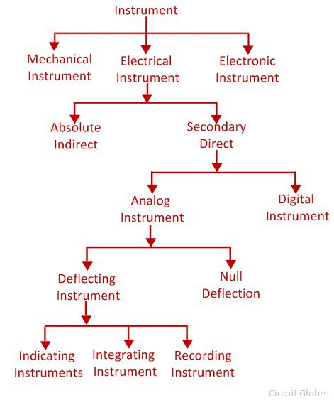](https://circuitglobe.com/wp-content/uploads/2017/11/types-of-measuring-instrument.jpg)

 In this article, we discuss the different types of electrical instrument.

**Absolute Instrument**

The absolute instrument gives the value of measures quantities regarding the physical constant. The physical constant means the angle of deflection, degree and meter constant. The mathematical calculation requires for knowing the value of a physical constant.

The tangent [galvanometer](https://circuitglobe.com/galvanometer.html) is the examples of the absolute instruments. In tangent galvanometer, the magnitude of current passes through the coil determines by the tangent of the angle of deflection of their coil, the horizontal component of the earth magnetic field, radius and the number of turns of wire used. The most common applications of this type of instrument are found in laboratories.

**Secondary Instrument**

In the secondary instrument, the deflection shows the magnitude of the measurable quantities**.** The calibration of the instruments with the standard instrument is essential for the measurement. The output of this type of device is directly obtained, and no mathematical calculation requires for knowing their value.

**Digital Instrument**

The digital instrument gives the output in the numeric form**.** The instrument is more accurate as compared to the analogue instrument because no human error occurs in the reading.

**Analog instrument**

The instrument whose output varies continuously is known as the analogue instrument. The analogue instrument has the pointer which shows the magnitude of the measurable quantities. The analogue device classifies into two types.

Null Type Instrument

In this instrument, the zero or null deflection indicates the magnitude of the measured quantity. The instrument has high accuracy and sensitivity.  In null deflection instrument, the one known and one unknown quantity use. When the value of the known and the unknown measuring quantities are equal, the pointer shows the zero or null deflection. The[null deflection instrument](https://circuitglobe.com/null-type-instrument.html) is used in the [potentiometer](https://circuitglobe.com/potentiometer-pot.html) and in galvanometer for obtaining the null point.

Deflection Type Instrument

The instrument in which the value of measuring quantity is determined through the deflection of the pointer is known as the deflection type instrument. The measuring quantity deflects the pointer of the moving system of the instrument which is fixed on the calibrated scale. Thus, the magnitude of the measured quantity is known.

The deflection type instrument is further sub-classified into three types.

1. **Indicating Instrument** – The instrument which indicates the magnitude of the measured quantity is known as the indicating instrument**.** The indicating instrument has the dial which moves on the graduated dial. The voltmeter, ammeter, [power factor meter](https://circuitglobe.com/power-factor-meter.html) are the examples of the indicating instrument.
2. **Integrating Instrument** – The instrument which measures the total energy supplied at a particular interval of time is known as the integrating instrument. The total energy measured by the instrument is the product of the time and the measures electrical quantities. The [energy meter](https://circuitglobe.com/energy-meter.html), watt-hour meter and the energy meter are the examples of [integrating instrument.](https://circuitglobe.com/integrating-instrument.html)
3. **Recording Instrument** – The instrument records the circuit condition at a particular interval of time is known as the recording instrument**.** The moving system of the recording instrument carries a pen which lightly touches on the paper sheet. The movement of the coil is traced on the paper sheet. The curve drawn on the paper shows the variation in the measurement of the electrical quantities.

The response time of the electronic instrument is very high as compared to the electrical and mechanical device.

**1.2.Static characteristics:**

#### The set of criteria defined for the instruments, which are used to measure the quantities which are slowly varying with time is called ‘static characteristics’.

**The various static characteristics are:**  
  
i) Accuracy  
  
ii) Precision  
  
iii) Sensitivity  
  
iv) Linearity  
  
v) Reproducibility  
  
vi) Repeatability  
  
vii) Resolution  
  
viii) Threshold  
  
ix) Drift  
  
x) Stability  
  
xi) Tolerance  
  
xii) Range or span  
  
**Accuracy:**  
  
It is the degree of closeness with which the reading approaches the true value of the quantity to be measured. The accuracy can be expressed in following ways:  
  
**a) Point accuracy:**  
  
Such accuracy is specified at only one particular point of scale.  
It does not give any information about the accuracy at any other Point on the scale.  
  
**b) Accuracy as percentage of scale span:**  
  
When an instrument as uniform scale, its accuracy may be expressed in terms of scale range.  
  
**c) Accuracy as percentage of true value:**  
  
The best way to conceive the idea of accuracy is to specify it in terms of the true value of the quantity being measured.

**Precision:** It is the measure of reproducibility i.e., given a fixed value of a quantity, precision is a measure of the degree of agreement within a group of measurements.

**Sensitivity:**  
  
The sensitivity denotes the smallest change in the measured variable to which the instrument responds. It is defined as the ratio of the changes in the output of an instrument to a change in the value of the quantity to be measured. Mathematically it is expressed as,  
[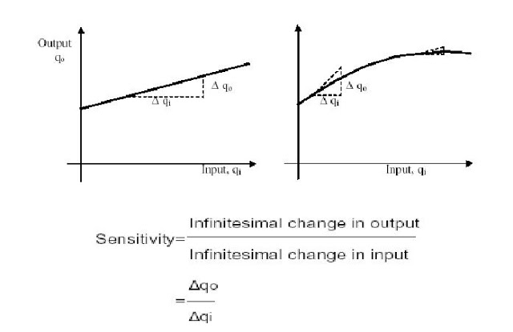](https://4.bp.blogspot.com/--BosshAsjNE/TxMDbjsxMsI/AAAAAAAAD_k/mxZakJl0yMA/s1600/untitled.JPG)

Thus, if the calibration curve is liner, as shown, the sensitivity of the instrument is the slope of the calibration curve. If the calibration curve is not linear as shown, then the sensitivity varies with the input. Inverse sensitivity or deflection factor is defined as the reciprocal of sensitivity. Inverse sensitivity or deflection factor = 1/ sensitivity

[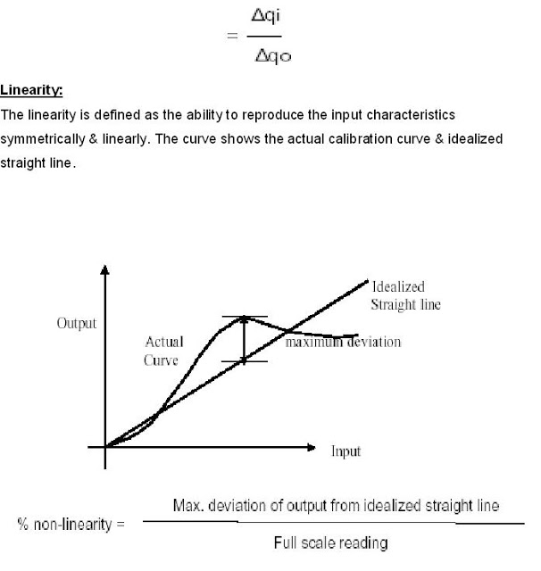](https://2.bp.blogspot.com/-7QMSMMBUFJU/TxMEKvw_JzI/AAAAAAAAD_s/tQl-KWaw6CY/s1600/untitled.JPG)

**Reproducibility:**  
  
It is the degree of closeness with which a given value may be repeatedly measured. It is specified in terms of scale readings over a given period of time.  
  
**Repeatability:**  
  
It is defined as the variation of scale reading & random in nature Drift:   
Drift may be classified into three categories:  
 **a) zero drift:**  
  
If the whole calibration gradually shifts due to slippage, permanent set, or due to undue warming up of electronic tube circuits, zero drift sets in.

[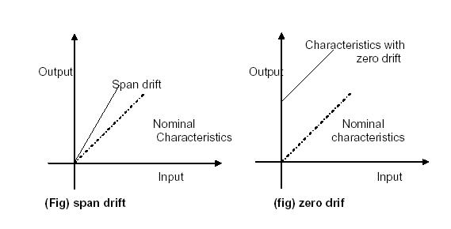](https://1.bp.blogspot.com/-fqu7a7Ueqjk/TxMEmWpFCaI/AAAAAAAAD_0/EodoMTFiHSU/s1600/untitled.JPG)

**b) span drift or sensitivity drift**  
  
If there is proportional change in the indication all along the upward scale, the drifts is called span drift or sensitivity drift.  
  
**c) Zonal drift:**  
  
In case the drift occurs only a portion of span of an instrument, it is called zonal drift.  
  
**Resolution:**  
  
If the input is slowly increased from some arbitrary input value, it will again be found that output does not change at all until a certain increment is exceeded. This increment is called resolution.  
  
**Threshold:**  
  
If the instrument input is increased very gradually from zero there will be some minimum value below which no output change can be detected. This minimum value defines the threshold of the instrument.  
 **Stability:**  
  
It is the ability of an instrument to retain its performance throughout is  
specified operating life.  
  
**Tolerance:**  
  
The maximum allowable error in the measurement is specified in terms of some value which is called tolerance.  
 **Range or span:**  
  
The minimum & maximum values of a quantity for which an instrument is designed to measure is called its range or span.

#### 1.3.Dynamic Characteristics:

#### The set of criteria defined for the instruments, which are changes rapidly with time, is called ‘dynamic characteristics’.

**Speed of response :**– its defined as the when we changed in input value and how much rapidly we get the change in output value by instruments. by this we can get the system is how much fast and active.

**Measuring lag:-**It is the retardation or delay in the response of a measurement system to changes in the measured quantity. The measuring lags are of two types:

1) **Retardation type:-**In this case the response of the measurement system begins immediately after the change in measured quantity has occurred.

2) **Time delay lag:-**In this case the response of the measurement system begins after a dead time after the application of the input.

**Fidelity:** It is defined as the degree to which a measurement system indicates changes in the measured quantity without dynamic error.

**Dynamic error:-**It is the difference between the true value of the quantity changing with time & the value indicated by the measurement system if no static error is assumed. It is also called measurement error.

**1.4.Error and its Types:**

### True Value

It is not possible to determine the true of quantity by experiment means. True value may be defined as the average value of an infinite number of measured values when average deviation due to various contributing factor will approach to zero.

### Measured Value

It may be defined as the approximated value of true value. It can be found out by taking means of several measured readings during an experiment, by applying suitable approximations on physical conditions.  
Now we are in a position to define static error. Static error is defined as the difference of the measured value and the true value of the quantity.

**Error:** Deviation of measured value from true value is known as Error.

### Limiting Errors or Guarantee Errors :

The concept of guarantee errors can better clear if we study this kind of error by considering one example. Suppose there is a manufacturer who manufactures an [ammeter](https://www.electrical4u.com/ammeter/), now he should promises that the error in the ammeter is selling not greater the limit he sets. This limit of error is known as limiting errors or guarantee error.

### Relative Error or Fractional Error

It is defined as the ratio of the error and the specified magnitude of the quantity

## Types of Errors

Basically there are three **types of errors** on the basis; they may arise from the source.

### 1.Gross Errors

This category of errors includes all the human mistakes while reading, recording and the readings. Mistakes in calculating the errors also come under this category. For example while taking the reading from the meter of the instrument he may read 21 as 31. All these types of error are come under this category. Gross errors can be avoided by using two suitable measures and they are written below:

1. A proper care should be taken in reading, recording the data. Also calculation of error should be done accurately.
2. By increasing the number of experimenters we can reduce the gross errors. If each experimenter takes different reading at different points, then by taking average of more readings we can reduce the gross errors.

### 2.Systematic Errors

In order to understand these kinds of errors, let us categorize the systematic errors as

#### 2.1.Instrumental Errors

These errors may be due to wrong construction, calibration of the [measuring instruments](https://www.electrical4u.com/electrical-measuring-instruments-types-accuracy-precision-resolution-speed/). These types of error may be arises due to friction or may be due to hysteresis. These types of errors also include the loading effect and misuse of the instruments. Misuse of the instruments results in the failure to the adjust the zero of instruments. In order to minimize the gross [errors in measurement](https://www.electrical4u.com/errors-in-measurement-classification-of-errors/) various correction factors must be applied and in extreme condition instrument must be re-calibrated carefully.

#### 2.2.Environmental Errors

This type of error arises due to conditions external to instrument. External condition includes temperature, pressure, humidity or it may include external [magnetic field](https://www.electrical4u.com/what-is-magnetic-field/). Following are the steps that one must follow in order to minimize the environmental errors:

* Try to maintain the temperature and humidity of the laboratory constant by making some arrangements.
* Ensure that there should not be any external magnetic or electrostatic field around the instrument.

### 2.3 Observational Errors

As the name suggests these **types of errors** are due wrong observations. The wrong observations may be due to PARALLAX. In order to minimize the PARALLAX error highly accurate meters are required, provided with mirrored scales.

### 2.4.Random Errors

After calculating all systematic errors, it is found that there are still some [errors in measurement](https://www.electrical4u.com/errors-in-measurement-classification-of-errors/) are left. These errors are known as random errors. Some of the reasons of the appearance of these errors are known but still some reasons are unknown. Hence we cannot fully eliminate these kinds of error.

**1.5.Essentials of Indicating instruments:**

An indicating instrument essentially consists of a moving system pivoted in jewel bearings. A pointer is attached to the moving system which indicates the electrical quantity to be measured, on a graduated scale. In order to ensure the proper operation of the indicating instruments , the following three torques are required.

1. Deflecting (or operating) torque.
2. Controlling (or restoring) torque.
3. Damping torque

The ***deflecting torque*** is produced by utilising the various effects (magnetic effect, induction effect, thermal effect, hall effect) of electric current or voltage, and causes the moving system and hence the pointer to move from  zero position.

The ***controlling torque*** is produced by spring or gravity and opposes the deflecting torque. The pointer comes to rest at a position, where these two opposing torques are equal.

***Damping torque*** is provided by air friction or eddy currents. It ensures that, the pointer comes to the final position, without oscillations, thus enabling accurate and quick readings to  be taken.

1. **Deflecting torque(Td) :-**The deflecting torque causes the moving system to move from zero position to indicate the value of the electrical quantity being measured on a graduated scale. The actual method of producing the deflecting torque depends upon the type of instrument.

Deflectinf Torque is achieved by utilizing the various effects of electric current or voltage. The deflecting torque causes the moving system to move from its zero position. The deflecting torque is produced by utilizing one or more of the following effects of current or voltage:

1. Magnetic effect ------------------------------- Moving-iron instruments.
2. Electrodynamic effect ---------------------- (i) Moving coil instruments,    (ii)Dynamometertype.
3. Electromagnetic induction effect ---------Induction type instruments.
4. Thermal effect ---------------------------------Hot-wire instruments.
5. Chemical effect --------------------------------Electrolytic instruments.
6. Electrostatic effect ----------------------------Electrostatic voltmeters

**(ii)**      **Controlling torque(Tc):-**

If the deflecting torque were acting alone, the pointer will continue to move indefenitely and would swing over to the maximum deflected position irrespective of the magnitude of the electrical quantity to be measured. This necessitates providing some form of controlling or opposing torque. This controlling torque should increase with the deflection of the moving system. The pointer will be brought to rest at a position where the two opposing torques are equal. ie, Td= Tc .

The controlling torque performs two functions.

a)      It increases with the deflection of the moving system so that, the final position of the pointer on the scale will be according to the magnitude of the electrical quantity to be measured.

b)      It brings the pointer back to zero position, when the deflecting torque is removed. If it were not provided, the pointer once deflected would not return to zero position on removing the deflecting torque.

 The controlling torque can be provided,

1. by using one or more springs
2. by the weight of moving parts

(i) **Spring control**: Fig. 1 shows a commonly used spring control arrangement. It utilises two spiral hair springs, 1 and 2, the inner ends of which are attached to the spindle S. The outer end of spring 2 is fixed while that of 1 is attached to a lever, the adjustment of which gives zero adjustments.

[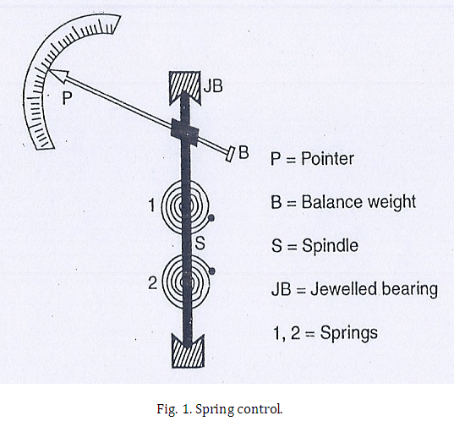](http://www.electrical-engineering-assignment.com/wp-content/uploads/2014/02/1.jpg)

The two springs 1 and 2 are wound in opposite directions so that when the moving system is deflected, one spring winds up while the other unwinds, and the controlling torque is due to the combined torsions of the springs.

Since the torsional torque of a spiral spring is proportional to the angle of twist, the controlling torque (Tc) is directly proportional to the angular deflection of the pointer (θ).

Tc  ∝ θ

The spring material should have the following properties:

(i) It should be non-magnetic.

(ii) It must be of low temperature co-efficient.

(iii) It should have low specific resistance.

(iv) It should not be subjected to fatigue.

**(ii)Gravity Control Method:**

[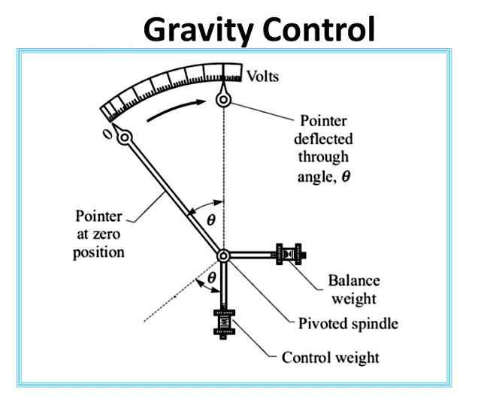](https://2.bp.blogspot.com/-Kpl8qxMHW8E/WRapHJhddnI/AAAAAAAACL0/gSzVQ3FMXPk00Xz4Jsad-Rcv9cioqstUQCLcB/s1600/gravity-control-damping-torque.jpg)

In this method, a small weight is attached to the moving system, which provides necessary controlling torque. In the zero position of the pointer, the control weight hangs vertically downward and therefore provides no controlling torque.  
  
However, under the action of deflecting torque, the pointer moves from zero position and control weight moves in opposite direction. Due to gravity, the control weight would tend to come in original position (i.e. vertical) and thus provides an opposing or controlling torque. The pointer comes to rest at a position where controlling torque is equal to the deflecting torque.  
  
In this method, controlling torque (Tc) is proportional to the sin of angle of deflection (θ) i.e.   
  
Tc α sin θ.

Because in this method controlling torque (Tc) is not directly proportional to the angle of deflection (θ) but it is proportional to sin θ therefore, gravity control instruments have non-uniform scales; being crowded in beginning.

**(iii)**    **Damping torque (Tdamp):-**

If the moving system is acted upon by deflecting and controlling torques alone, then due to inertia, the pointer will oscillate about its final deflected position for some time before coming to rest. This oscillation makes it difficult to obtain quick and accurate reading. Inorder to avoid these oscillations of the pointer and to bring it quickly to its final deflected position, a damping torque is provided in the indicating instruments. The damping do not affect the stationary pointer, as the damping torque acts only when the pointer is in motion and always opposes the motion.

The damping torque in indicating instruments can be provided by,

(i) Air- friction

(ii)Fluid friction

(iii) Eddy currents

The behaviour of the moving system is decided by the degree of damping. The fig.  given below shows the graph for under damping, over damping, and critical damping.

[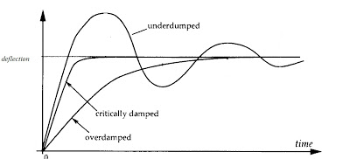](http://4.bp.blogspot.com/-Y7sOUBCWA9M/UN6TuNSWV0I/AAAAAAAAAek/fdrI6UBC6sg/s1600/damp.jpg)

***Under damped moving system*:-**The pointer will oscillate about the final position for some time, before coming to rest.

***Over damped:-***  The pointer will become slow and lethargic.

***Critically damped/ dead beat:-*** The degree of damping is so that, the pointer comes up to the correct reading quickly without passing beyond it or oscillating about it.

### 1. Air Friction damping:

The air friction damping device is as shown in the figure below. The arrangement consists of a light aluminium piston which is attached to the moving system. This piston moves in a fixed air chamber which is closed at one end. The clearance between piston and the chamber walls is uniform throughout and is very small. When there are oscillations the piston moves into and out of air chamber. When the piston moves inside the chamber, the air inside is compressed and pressure of air, thus builds up, opposes the motion of piston and hence the whole moving system. When the piston moves out of the air chamber, pressure in the closed space falls, and the pressure on the open side of piston is greater than on the other side. Thus there is again an opposition to motion.

|  |
| --- |
| [https://2.bp.blogspot.com/-caj2ctYasPI/V3ZFLICTLJI/AAAAAAAABFg/JNuNVn5BIuk-YLFJrav0Xm_ziJKzVUcfQCLcB/s1600/air%2Bfriction%2Bdamping.jpg](https://2.bp.blogspot.com/-caj2ctYasPI/V3ZFLICTLJI/AAAAAAAABFg/JNuNVn5BIuk-YLFJrav0Xm_ziJKzVUcfQCLcB/s1600/air+friction+damping.jpg) |
| Air Friction Damping |

### 2. Fluid Friction damping:

This form of damping is similar to air friction damping. Oil is used in place of air and as the viscosity of oil is greater, the damping force is correspondingly greater.

A disc is attached to the moving system as shown in the figure, this disc dips into an oil pot and is completely submerged in oil. When the moving system moves, the disc moves in oil and a frictional drag is produced. This frictional drag always opposes the motion.

|  |
| --- |
| [https://2.bp.blogspot.com/-TIWrYStzbnU/V3ZFTXyjDGI/AAAAAAAABFk/Vi48kcykdGAKAN4_ce_yMnOWtwj4BwlAQCLcB/s1600/fluid%2Bfriction%2Bdamping.jpg](https://2.bp.blogspot.com/-TIWrYStzbnU/V3ZFTXyjDGI/AAAAAAAABFk/Vi48kcykdGAKAN4_ce_yMnOWtwj4BwlAQCLcB/s1600/fluid+friction+damping.jpg) |
| Fluid Friction Damping |

#### Advantages of fluid friction damping:

* Due to more viscosity of fluid, more damping is provided.
* The oil can also be used for insulation purposes.
* Due to upthrust of oil, the load on the bearings are reduced, thus reducing the frictional errors.

#### Disadvantages of fluid friction damping:

* These are used only for instruments in vertical position.
* Due to oil leakage, the instruments cannot be kept clean.

**3.Eddy Current Damping:**

[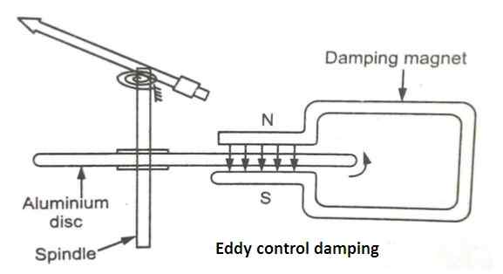](https://2.bp.blogspot.com/-uldU62u_ZkQ/WRapGkQ92FI/AAAAAAAACLk/7xxZSYGFP1004VSUDggzKNuHPK3KTBW6QCLcB/s1600/eddy-current-damping-torque.jpg)

The method of eddy current damping  shown in the figure, a thin aluminum or copper disc is attached to the moving system is allowed to pass between the poles of a permanent magnet. As the pointer moves, the disc cuts across the magnetic field and eddy currents are induced in the disc.   
  
These eddy currents react with the field of the magnet to produce a force which opposes the motion according to [Lenz's Law](http://www.yourelectricalguide.com/2017/05/important-laws-of-magnetism.html). In this way, eddy **current damping** torque reduces the oscillations of the pointer.